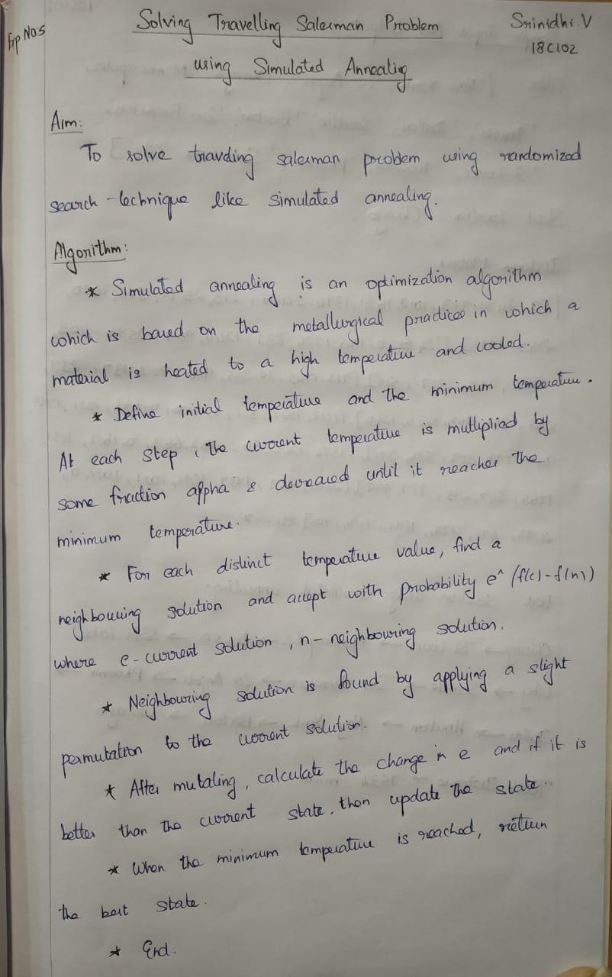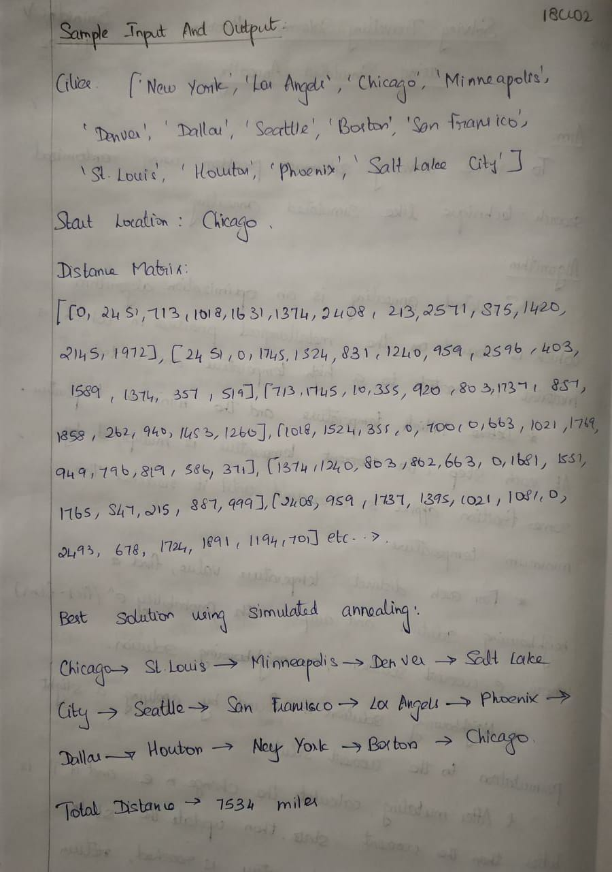

**Program:**

# Import libraries

import sys

import random

import copy

import numpy as np

# This class represent a state

class State:

# Create a new state

def __init__(self, route:[], distance:int=0):

self.route = route

self.distance = distance

# Compare states

def __eq__(self, other):

for i in range(len(self.route)):

if(self.route[i] != other.route[i]):

return False

return True

# Sort states

def __lt__(self, other):

return self.distance < other.distance

# Print a state

def __repr__(self):

return ('({0},{1})\n'.format(self.route, self.distance))

# Create a shallow copy

def copy(self):

return State(self.route, self.distance)

# Create a deep copy

def deepcopy(self):

return State(copy.deepcopy(self.route), copy.deepcopy(self.distance))

# Update distance

def update_distance(self, matrix, home):

# Reset distance

self.distance = 0

# Keep track of departing city

from_index = home

# Loop all cities in the current route

for i in range(len(self.route)):

self.distance += matrix[from_index][self.route[i]]

from_index = self.route[i]

# Add the distance back to home

self.distance += matrix[from_index][home]

# This class represent a city (used when we need to delete cities)

class City:

# Create a new city

def __init__(self, index:int, distance:int):

self.index = index

self.distance = distance

# Sort cities

def __lt__(self, other):

return self.distance < other.distance

# Return true with probability p

def probability(p):

return p > random.uniform(0.0, 1.0)

# Schedule function for simulated annealing

def exp_schedule(k=20, lam=0.005, limit=1000):

return lambda t: (k * np.exp(-lam * t) if t < limit else 0)

# Get the best random solution from a population

def get_random_solution(matrix:[], home:int, city_indexes:[], size:int, use_weights:bool=False):

# Create a list with city indexes

cities = city_indexes.copy()

# Remove the home city

cities.pop(home)

# Create a population

population = []

for i in range(size):

if(use_weights == True):

state = get_random_solution_with_weights(matrix, home)

else:

# Shuffle cities at random

random.shuffle(cities)

# Create a state

state = State(cities[:])

state.update_distance(matrix, home)

# Add an individual to the population

population.append(state)

# Sort population

population.sort()

# Return the best solution

return population[0]

# Get best solution by distance

def get_best_solution_by_distance(matrix:[], home:int):

# Variables

route = []

from_index = home

length = len(matrix) - 1

# Loop until route is complete

while len(route) < length:

# Get a matrix row

row = matrix[from_index]

# Create a list with cities

cities = {}

for i in range(len(row)):

cities[i] = City(i, row[i])

# Remove cities that already is assigned to the route

del cities[home]

for i in route:

del cities[i]

# Sort cities

sorted = list(cities.values())

sorted.sort()

# Add the city with the shortest distance

from_index = sorted[0].index

route.append(from_index)

# Create a new state and update the distance

state = State(route)

state.update_distance(matrix, home)

# Return a state

return state

# Get a random solution by using weights

def get_random_solution_with_weights(matrix:[], home:int):

# Variables

route = []

from_index = home

length = len(matrix) - 1

# Loop until route is complete

while len(route) < length:

# Get a matrix row

row = matrix[from_index]

# Create a list with cities

cities = {}

for i in range(len(row)):

cities[i] = City(i, row[i])

# Remove cities that already is assigned to the route

del cities[home]

for i in route:

del cities[i]

# Get the total weight

total_weight = 0

for key, city in cities.items():

total_weight += city.distance

# Add weights

weights = []

for key, city in cities.items():

weights.append(total_weight / city.distance)

# Add a city at random

from_index = random.choices(list(cities.keys()), weights=weights)[0]

route.append(from_index)

# Create a new state and update the distance

state = State(route)

state.update_distance(matrix, home)

# Return a state

return state

# Mutate a solution

def mutate(matrix:[], home:int, state:State, mutation_rate:float=0.01):

# Create a copy of the state

mutated_state = state.deepcopy()

# Loop all the states in a route

for i in range(len(mutated_state.route)):

# Check if we should do a mutation

if(random.random() < mutation_rate):

# Swap two cities

j = int(random.random() * len(state.route))

city_1 = mutated_state.route[i]

city_2 = mutated_state.route[j]

mutated_state.route[i] = city_2

mutated_state.route[j] = city_1

# Update the distance

mutated_state.update_distance(matrix, home)

# Return a mutated state

return mutated_state

# Simulated annealing

def simulated_annealing(matrix:[], home:int, initial_state:State, mutation_rate:float=0.01, schedule=exp_schedule()):

best_state = initial_state

for t in range(sys.maxsize):

T = schedule(t)

if T == 0:

return best_state

neighbor = mutate(matrix, home, best_state, mutation_rate)

delta_e = best_state.distance - neighbor.distance

if delta_e > 0 or probability(np.exp(delta_e / T)):

best_state = neighbor

# The main entry point for this module

def main():

# Cities to travel

cities = ['New York', 'Los Angeles', 'Chicago', 'Minneapolis', 'Denver', 'Dallas', 'Seattle', 'Boston', 'San Francisco', 'St. Louis', 'Houston', 'Phoenix', 'Salt Lake City']

city_indexes = [0,1,2,3,4,5,6,7,8,9,10,11,12]

# Index of start location

home = 2 # Chicago

# Distances in miles between cities, same indexes (i, j) as in the cities array

matrix = [[0, 2451, 713, 1018, 1631, 1374, 2408, 213, 2571, 875, 1420, 2145, 1972],

[2451, 0, 1745, 1524, 831, 1240, 959, 2596, 403, 1589, 1374, 357, 579],

[713, 1745, 0, 355, 920, 803, 1737, 851, 1858, 262, 940, 1453, 1260],

[1018, 1524, 355, 0, 700, 862, 1395, 1123, 1584, 466, 1056, 1280, 987],

[1631, 831, 920, 700, 0, 663, 1021, 1769, 949, 796, 879, 586, 371],

[1374, 1240, 803, 862, 663, 0, 1681, 1551, 1765, 547, 225, 887, 999],

[2408, 959, 1737, 1395, 1021, 1681, 0, 2493, 678, 1724, 1891, 1114, 701],

[213, 2596, 851, 1123, 1769, 1551, 2493, 0, 2699, 1038, 1605, 2300, 2099],

[2571, 403, 1858, 1584, 949, 1765, 678, 2699, 0, 1744, 1645, 653, 600],

[875, 1589, 262, 466, 796, 547, 1724, 1038, 1744, 0, 679, 1272, 1162],

[1420, 1374, 940, 1056, 879, 225, 1891, 1605, 1645, 679, 0, 1017, 1200],

[2145, 357, 1453, 1280, 586, 887, 1114, 2300, 653, 1272, 1017, 0, 504],

[1972, 579, 1260, 987, 371, 999, 701, 2099, 600, 1162, 1200, 504, 0]]

# Get the best route by distance

state = get_best_solution_by_distance(matrix, home)

print('-- Best solution by distance --')

print(cities[home], end='')

for i in range(0, len(state.route)):

print(' -> ' + cities[state.route[i]], end='')

print(' -> ' + cities[home], end='')

print('\n\nTotal distance: {0} miles'.format(state.distance))

print()

# Get the best random route

state = get_random_solution(matrix, home, city_indexes, 100)

print('-- Best random solution --')

print(cities[home], end='')

for i in range(0, len(state.route)):

print(' -> ' + cities[state.route[i]], end='')

print(' -> ' + cities[home], end='')

print('\n\nTotal distance: {0} miles'.format(state.distance))

print()

# Get a random solution with weights

state = get_random_solution(matrix, home, city_indexes, 100, use_weights=True)

print('-- Best random solution with weights --')

print(cities[home], end='')

for i in range(0, len(state.route)):

print(' -> ' + cities[state.route[i]], end='')

print(' -> ' + cities[home], end='')

print('\n\nTotal distance: {0} miles'.format(state.distance))

print()

# Run simulated annealing to find a better solution

state = get_best_solution_by_distance(matrix, home)

state = simulated_annealing(matrix, home, state, 0.1)

print('-- Simulated annealing solution --')

print(cities[home], end='')

for i in range(0, len(state.route)):

print(' -> ' + cities[state.route[i]], end='')

print(' -> ' + cities[home], end='')

print('\n\nTotal distance: {0} miles'.format(state.distance))

print()

# Tell python to run main method

if __name__ == "__main__": main()

**Output:**

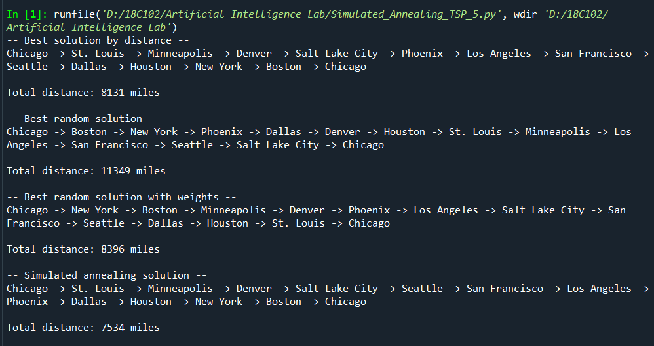

**Result:**

Thus the travelling salesman problem is solved using randomized search technique simulated annealing.